**MATLAB TOOLBOX INSTALLATION**

In your MATLAB, go to “HOME” at the top bar and select the dropdown arrow of the “Add-Ons”. Then select “Get Add-Ons”

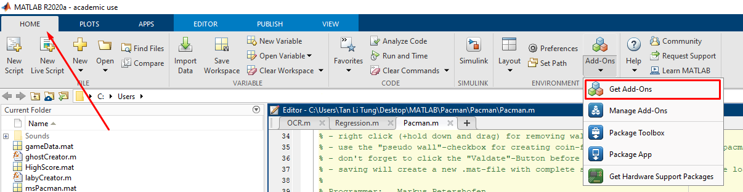

The Add-on Explorer will pop-up. In the search bar, search for “Computer Vision”, and select the one shown in the Figure below:

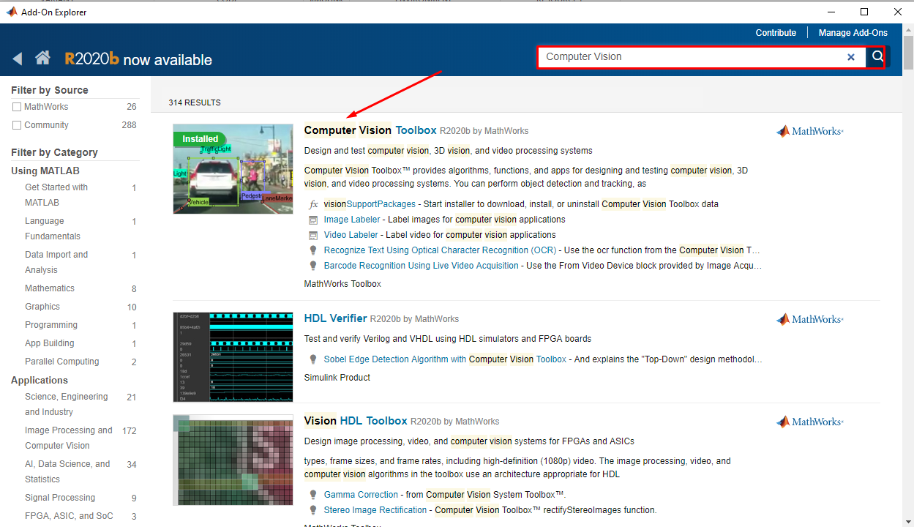

In the toolbox, select “Sign in to Install” or “Install”



Search for “Simscape” in the search bar of the Add-On Explorer. Repeat the installation for Simscape and Simscape Electrical.

